**Program design document**

**JAVASOCIAL**

Developer team:

**Batuhan DERYA 191ADB067**

Submission deadline:

**14.04.2020**

Content

1 Introduction 3

1.1 Document Purpose 3

1.2 Definitions, Acronyms and Abbreviations 3

1.3 References 3

2 Program overall description 4

3 Program architecture 5

3.1 Architecture design 5

4 Data dictionary 7

5 Program algorithms 8

5.1 Program algorithm A 8

5.1.1 Functions of component A 8

5.2 Program algorithm B 9

5.2.1 Functions of component B 9

# Introduction

## Document Purpose

The purpose of this document is to introduce the social media platform that I have encoded through the java program, to introduce the code and to give information about the program. In this file, the design, function and programming of the program will be mentioned.

## Definitions, Acronyms and Abbreviations

I used my native language, Turkish, when coding the program. I will write their English equivalents.  
kullanıcı=user  
durum=status

## References

<https://www.lucidchart.com/>

# Program overall description

Program has five class. These are UserPanel,message,post,timeline and users. Users class keeps the user information. It has methods. These are accessor and mutator methods. In this way,we can access user data and add data. This class is the subclass of the message class. The message class is used to keep incoming and outgoing messages to users.   
  
  
Message class is the subclass of the timeline class. Timeline class is used to store the posts that users share. Post class holds the user's own posts. UserPanel class is the main class associated with all classes. Users' data get and processed from this class. The program first asks you to enter a value. If there is no user in your program, you should create the user first.   
  
  
If the user is created, you can continue by pressing 2.In this way, we created dynamically users. We created our users and transferred their information to the arraylist. Program wants to us choose a user here. After selecting a user, we need to select a operation.   
  
  
Users' posts are added to the timeline and only those users who follow are able to see them. We can look at the timeline of the person being followed. We can share and like their posts. In addition,likes and shares are added to the notification box.

# Program architecture

## Architecture design

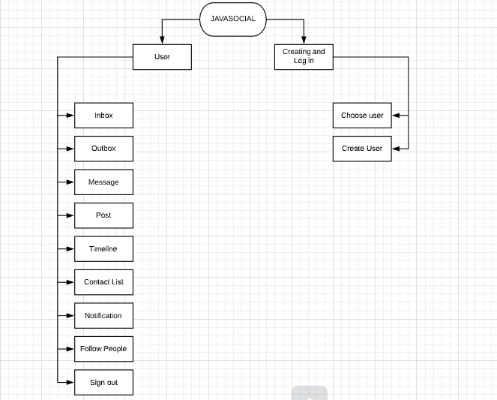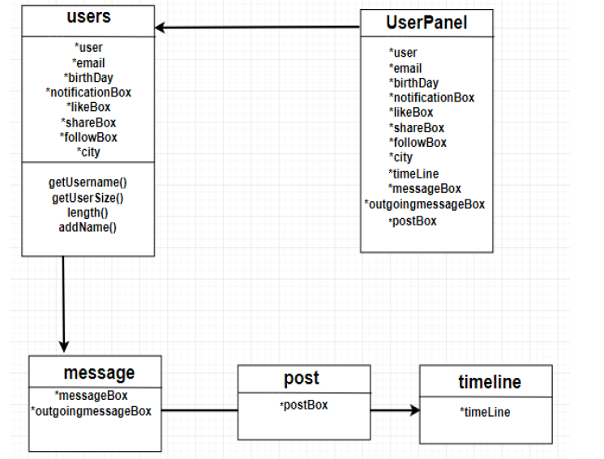

# Data dictionary

<List and describe all data instances consumed or produced by the program (input/output data).>

|  |  |  |  |  |
| --- | --- | --- | --- | --- |
| **Name** | **Description** | **Type** | **Range of values** | **Length** |
| Userc | Creating new user | Integer | - | - |
| Menu | User menu | Integer | 1-9+(-1) | - |
| Message | Choosing a user to message | Integer | - | - |
| Durum | Choosing log in or create new user | Integer | 1-2 | - |
| Choose | User will choose button here; like button, share button and continue button. | Integer | 1-3 | - |
| Follow | You choose who to follow | Integer | - | - |
| Timeline | Keeping the timeline number of users | Integer | - | - |
| usermessages | It works to write and send messages | String | Latin alphabet capital and lowercase letters | - |
| Posts | Posting and sharing status | String | Latin alphabet capital and lowercase letters | - |
| Kullanici | Storing the user's data and user identification | Arraylist | It is a collection object used to store a data set, such as an array structure. | - |
| Email | E-mail address is written | String | Latin alphabet capital and lowercase letters | - |
| Birthday | Birthday is written | String | Latin alphabet capital and lowercase letters | - |

# Program algorithms

“Create new user” and “Timeline” function of the program

## Program algorithm A

The person who will use the program needs a user, so we create the user by selecting the "create new user" option. Creates a new user by entering their name, surname, birthday date, location, information. With the parameters that the user enters, a new user is created.

### Functions of component A

- Enter name and surname  
-Scan Input  
- Enter location information  
-Scan Input  
- Enter date of birth  
-Scan Input  
- The entered values ​​and parameters are saved by going to the data   
- User created

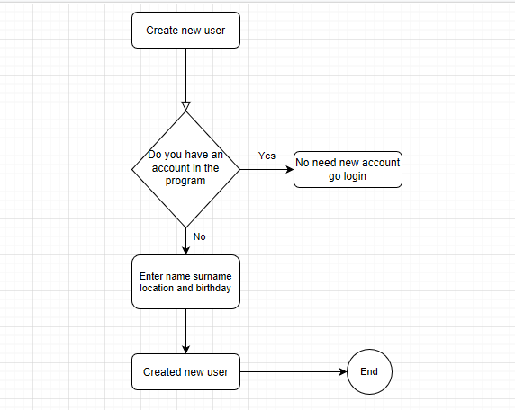

## Program algorithm B

In this algorithm, entering the timeline and liking status, sharing status. By selecting the timeline from the menu, we select that user if we want to see the timeline here.

### Functions of component B

-Select timeline  
- select the timeline of one of the users  
- If the user has shared status, he / she can like,share or continue  
-End

